Student Assessment Submission and Declaration
When submitting evidence for assessment, each student must sign a declaration confirming that the work is their own.
Student name: Adel Mohammed Adel Shurab |  | Assessor name:  Ali Mahmoud
Issue date: 29/11/2021 | Submission date: 06/01/2022 |  | Submitted on:  9/1/2022
Programme:

Unit: 2.Networking
Assignment number and title:
Research and Implementing a Wireless Network

Plagiarism
Plagiarism is a particular form of cheating. Plagiarism must be avoided at all costs and students who break the rules, however innocently, may be penalised. It is your responsibility to ensure that you understand correct referencing practices. As a university level student, you are expected to use appropriate references throughout and keep carefully detailed notes of all your sources of materials for material you have used in your work, including any material downloaded from the Internet. Please consult the relevant unit lecturer or your course tutor if you need any further advice.

Task A
Switches :
switches are the foundation of most business networks. A switch acts as a controller , connecting computers , printers , and servers to a network in a building or a campus.
There are two basic types of switches to choose from as part of your networking basics : on-premises and cloud -managed.
A managed on-premises switch lets you configure and monitor your LAN , giving you tighter control of your network traffic.
Routers :
Routers are devices that connect different networks. They also have access to the Internet for computers on those networks. Routers save money by allowing all devices connected to the network to share a common Internet connection.
The router performs the role of the sender. It analysis the data transmitted over the network, determines the best path for the data to take, and sends it on its way.
Access point: It is a device that connects wireless devices to form what is called a wireless network. ... Several wireless access points can also communicate with each other to form a larger network allowing wireless devices to stay connected in a larger area.
-2 Cat8 Ethernet Cable, Outdoor&Indoor, 6FT Heavy Duty High Speed 26AWG Cat8 LAN Network Cable 40Gbps, 2000Mhz with Gold Plated RJ45 Connector, Weatherproof S/FTP UV Resistant for Router
-3 Topology Of A Tree :
This design is used for large networks, not for small networks, and is mainly used in a network that covers a large area, and its advantages are that it reduces network traffic, is flexible to use, and has centralized monitoring and easy detection of errors.
4- 1- I have used Linksys router I chose this type because it is famous and has many advantages
2-Speed up to 1.8 Gbps.
3-Encryption protocol is AES
5- Compare between weird and wireless network
 | Wired network | Wireless network
speed | High up to 100 | Low up to 53
cost | cheap | Expensive
Quality of service | better | poor
security | good | weak
Devices used | switches | routers
cables | Ethernet, copper and optical fibers | Works on radio waves and microwaves

6- Compare table
Standard | Max speed | Typical Range
802.11a | 54mbps | 150 feet
802.11g | 11mbps | 300 feet
802.11ac | 433mbps-1733mbps | 300+feet

The best price is 150$for Linksys MAX-STREAM Mesh WiFi 6 Router (MR7350)
The price of cable is 15$ dollar
7-list of server
DNS | Because it is useful when entering a specific site such as Wikipedia (wikipedia.org), and it is easy to access and memorize it by typing the name of the site, but it is difficult to mention the site's address, which is located on DNS 142 and in the file 2017. Network and contact addresses.
DHCB | The Dynamic Host Communication Protocol (DHCP) is used by a DHCP Server to configure the network settings of client computers.  Instead of manually configuring static IP addresses and other network settings on client computers in a large network, a DHCP server in the network configures these network settings dynamically for LAN devices.
PRINT SERVER | A computer or other device linked to one or more printers and capable of receiving print commands via a computer network from an external client computer. The data is subsequently sent to the relevant printer(s) that the print server maintains.
FILE SERVER | An FTP server is not the same as a File Server. This type of server is more modern, with the ability to "map" networked data to disks. This means that users can browse folders using their home computer's file browser.

8- Domain Name System (DNS) : Naming scheme for machines, utilities, and other objects connecting to the Internet or a private network. It links different pieces of information to domain names assigned to each of the participants.
DHCP Server is a network server that assigns IP addresses, default gateways, and other network parameters to client devices on a regular basis. To react to broadcast requests from clients, it uses the Dynamic Host Configuration Protocol, or DHCP, as a regular protocol.
A DHCP server sends the appropriate network parameters to clients so that they can interact properly on the network.
Task B
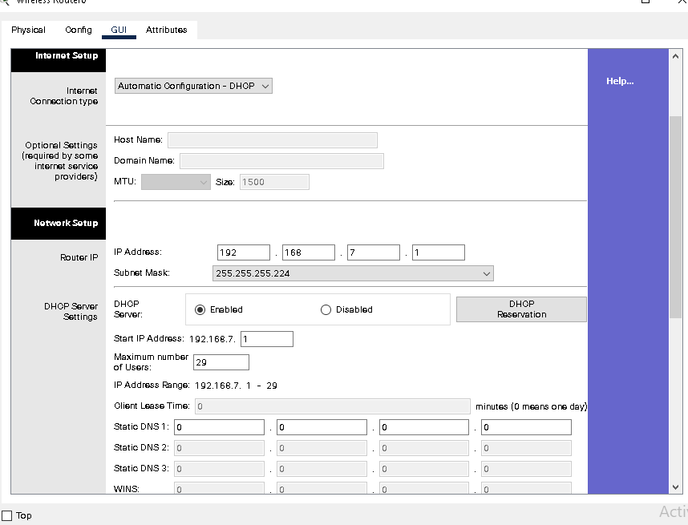
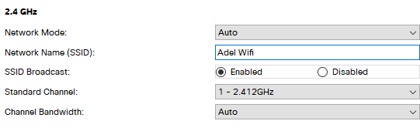
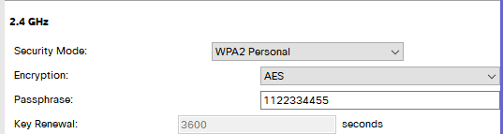
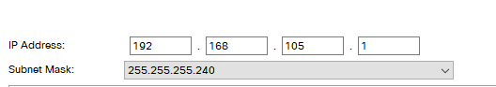
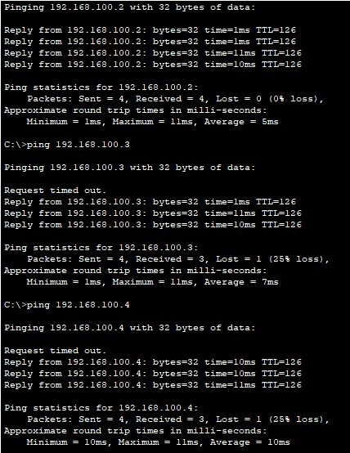
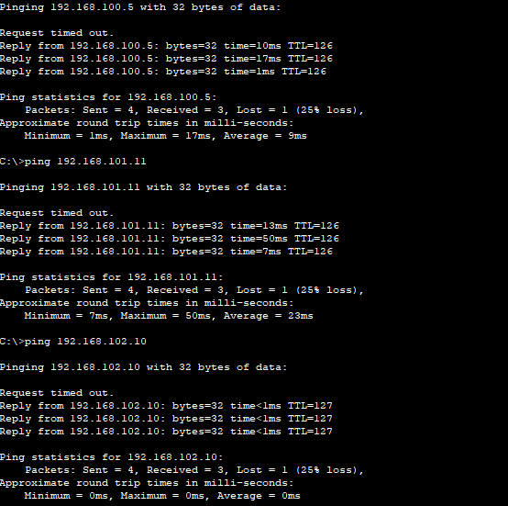
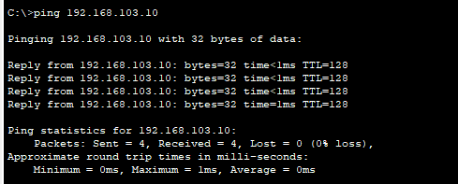
Task D
What Is Network Maintenance?
Network maintenance, at its most basic level, entails all of the processes and systems in place to monitor, upgrade, and run your company's computer network before problems arise.
Your full portfolio of physical IT assets, such as servers and hardware, as well as non-physical IT assets, such as software and cloud access, is referred to as your IT ecosystem.
A robust IT ecosystem, like other company processes, relies on proactive, daily activity and strategic vision rather than reactive, spur-of-the-moment patching. The following are the essential tenets of network maintenance — and the foundation of a successful regular network maintenance plan:
1-Network Cyber security 2-Network performance 3-Network scalability
4-Regular hardware and software updates 5-IT infrastructure compliance
6-Preemptive network repairs
5 Routine Network Maintenance Tasks
- Keep an eye on the network firmware.
When it comes down to it, routers and switches are nothing more than PCs with a lot more ports. And, like computers, they run software that is vulnerable to bugs and security concerns, as well as feature rot if they aren't kept up to date.

There are numerous examples of network equipment that require firmware upgrades to fix serious security flaws that can
(a) compromise the network device itself and
(b) potentially compromise devices linked to that network device .

- Perform network capacity planning.
The current consumer hunger for bandwidth is voracious. The burden on the network—and the bandwidth necessary to sustain a user—increases as more services become cloud-based and each service becomes increasingly dynamic and data-rich.
At every layer of the network, keep an eye out for potential bottlenecks. The following are examples of network bottlenecks:
Switches' trunk connections
The firewall is connected to the core switch via an uplink.
The WAN connection from the local network to the Internet provided by the ISP.

Capacity of access points

Client capacity and radio (802.11)
Capacity for backhaul and uplink
- Keep an eye out for unknown devices.
Review what devices, device kinds, and vendors you expect to see on the network on a regular basis.
To see what's truly out there and whether it matches your expectations, use a program that delivers automated network inventory and network topology.
If something appears to be questionable, take action to investigate further.

- Review and harden the network's configurations for stability.

Users tampering with IT infrastructure, such as bringing in an unmanaged switch or a consumer-grade access point to connect several devices to corporate Wi-Fi, is frowned upon.

Harden the network as much as possible to only allow the devices you expect to be on it. This might be a mix of IP phone and workstation for each employee, or just a workstation if voice is handled by softphone or smartphone.
Consider limiting the number of MAC addresses per switchport. Allow PortFast, BPDU guard, storm control, and similar tools to prevent unauthorized devices from bringing your network down.

- Do regular security and credential reviews.
Securing the network from both internal and external threats
The operation and maintenance of a network are inextricably linked to network security. It is also critical that both internal and external threats be taken into account. While most businesses have a dedicated security staff, monitoring and a structured maintenance strategy can also be used to identify vulnerabilities or possible security risks, allowing for appropriate action to be done before an event occurs.
The most important features and ways to improve the network and maintain its security
First, the basics of protection must be provided
They are three stages
1-Protection
2- detection
3- respond
Second, network protection methods
Security in the network is achieved through a set of techniques and the necessary procedure to be followed, including the use of more than one method to increase security and the line of defense for the network
The lines of defense for the network are:
1-FireWall2-Accsess Control3-Antivairus Software4-Anti-malware Software5-Applcation Security6-Data loss prevention7-Email Security 8-SIEM 9-mobile device security
The wireless network has some measures that limit its exposure to penetration
- Change the name password periodically
- Limit network access
- The use of the SIEM system that collects and organizes records and conducts analyzes, infers events, issues reports to officials, and provides solutions to existing problems
- Network data encryption contributes to reducing data intruders through algorithms: WEP and WPA
- Installing a barrier between the trusted network and external networks. This is called a firewall
- Use antivirus and malware protection software

100000 Kbps = 100 Mbps
File size=6.59 MB = 6.59*8
= 52.72 Mb
T = 52.72 Mb / 100 Mbps
= 0.5272 s

The time increases because the router has a lot of pressure due to the many wires, so the actual time will be more than the expected time.

Reference
1-https://www.indeed.com/career-advice/career-development/types-of-servers
2-https://www.makeuseof.com/tag/understanding-common-wifi-standards-technology-explained/
3-https://www.linksys.com/us/c/wireless-routers/
4-https://www.amazon.com/Ethernet-Outdoor-Connector-Weatherproof-Resistant/dp/B07QLXC6QR
5-https://www.baeldung.com/cs/routers-vs-switches-vs-access-points

Student Declaration
Student declaration
I certify that the assignment submission is entirely my own work and I fully understand the consequences of plagiarism. I understand that making a false declaration is a form of malpractice.

Student signature: Adel shurab Date:9/1/2022

